AsiaCORD 2025 学術集会 抄録集広告掲載申込書
Application for advertisement in AsiaCORD 2025 meeting proceedings

Please fill out the form completely in English or Japanese and send to the addressee below by E-mail or FAX.
社名 Company name
所在地 Address
連絡責任者  Name of person in charge | 氏名 Name
 | 所属 Affiliation
TEL (0)
FAX (0)
E-mail
希望掲載箇所  Desired place | Please check one of them.  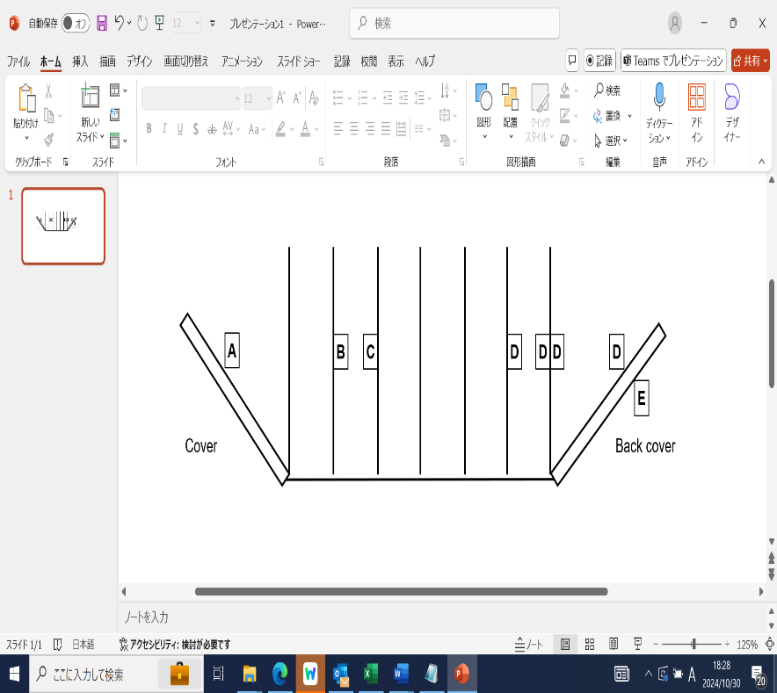  □ A. A4 full page; 150,000 yen  □ B. A4 full page; 110,000 yen  □ C. A4 full page; 120,000 yen  □ D. A4 full page; 90,000 yen  □ D. A4 half page; 45,000 yen  □ E. A4 full page; 140,000 yen
広告の版下データは、2025年2月28日までに下記e-mailへお送りください。A4フルページの場合は縦A4サイズ、A4ハーフページの場合は横A5サイズのファイルが必要となります。
Please send your advertising data to the e-mail address below by Feb.28, 2025. It is required to have A4 portrait file for A4 full page and A5 landscape file for A4 half page.

ご入金前に申請書のご提出が必要です。その後、選択した広告費を以下口座へ2025年3月31日までにお振込みください。
We need your application form. Please send the form by e-mail before a transfer. Advertising (A-E) you choosed must be made transfer to the bank account below by Mar. 31, 2025.
Beneficiary Name | AsiaCORD jimukyokusama
Beneficiary Address | 4-6-1, Shirokanedai, Minato-ku, Tokyo 108-8639
Beneficiary Bank Name | MIZUHO BANK, LTD.
Branch Name | SHIROGANE BRANCH (Branch #: 044)
Branch Address | HIROO BRANCH, 5-15-19 Minamiazabu, Minato-ku, Tokyo 106-0047
Account # | 1532504
SWIFT code/ BIC code | MHCBJPJT (If you need 11 digits, MHCBJPJTXXX)

AsiaCORD 2025 Meeting Secretariat
StemCell Institute Inc.
1-21-19, Toranomon, Minato-ku, Tokyo, Japan
E-mail: stemcell@stemcell.co.jp
Fax: +81-3-6811-3240

