STRUCTURE AND FUNCTION OF THE PotD PROTEIN IN THE SPERMIDINE-PREFERENTIAL UPTAKE SYSTEM

K. Igarashia, R. Pistocchia, S. Shibuyaa, S. Sugiyamab, K. Morikawab, and K. Kashiwagia

a Faculty of Pharmaceutical Sciences, Chiba University, 1-33 Yayoi-cyo, Inage-ku, Chiba 263, and b Protein Engineering Research Institute, 6-2-3 Furuedai, Suita Osaka 565, Japan

PotD protein is a periplasmic substrate binding protein in the spermidine-preferential uptake system in Escherichia coli. The crystal structure of PotD in complex with spermidine-has been solved at 2.5-Å resolution. PotD protein consists of two domains with an altering β-α-β topology. The polyamine binding site is in a central cleft lying in the interface between the domains.
Spermidine-binding sites on the PotD protein were studied by measuring polyamine transport activities of right-side-out membrane vesicles with mutated PotD proteins prepared by site-directed mutagenesis of the potD gene and by measuring polyamine binding activities of these mutated PotD proteins. Polyamine transport activities of the mutated PotD proteins paralleled their polyamine binding activities. It was found that Trp-34, Thr-35, Glu-36, Tyr-37, Ser-83, Tyr-85, Asp-168, Glu-171, Trp-229, Trp-255, Asp-257, Tyr-293, and Gln-327 of PotD protein were involved in the binding to spermidine. When spermidine uptake activities were measured in intact cells expressing the mutated PotD proteins, it was found that Glu-171, Trp-255, and Asp-257 were more strongly involved in the binding of spermidine to the PotD protein than the other amino acids listed above. The dissociation constants of spermidine for the mutated PotD proteins at Glu-171, Trp-255, and Asp-257 increased greatly in comparison with those for the other mutated PotD proteins. Since these three amino acids clearly interact with the diaminopropane moiety of spermidine, the results are in accordance with the finding that PotD protein has a higher affinity for spermidine than for putrescine. Putrescine was found to bind at the position of the diaminoibutane moiety of spermidine.

Keywords: Polyamine, Transport, PotD, Crystal structure.

References

1. Sugiyama, S., Vassylyev, D. G., Matsushima, M., Kashiwagi, K., Igarashi, K., and Morikawa, K. (1996) J. Biol. Chem. 271, 9519-9525.
2. Kashiwagi, K., Pistocchi, R., Shibuya, S., Sugiyama, S., Morikawa, K., and Igarashi, K. (1996) J. Biol. Chem. 271, 12205-12208.

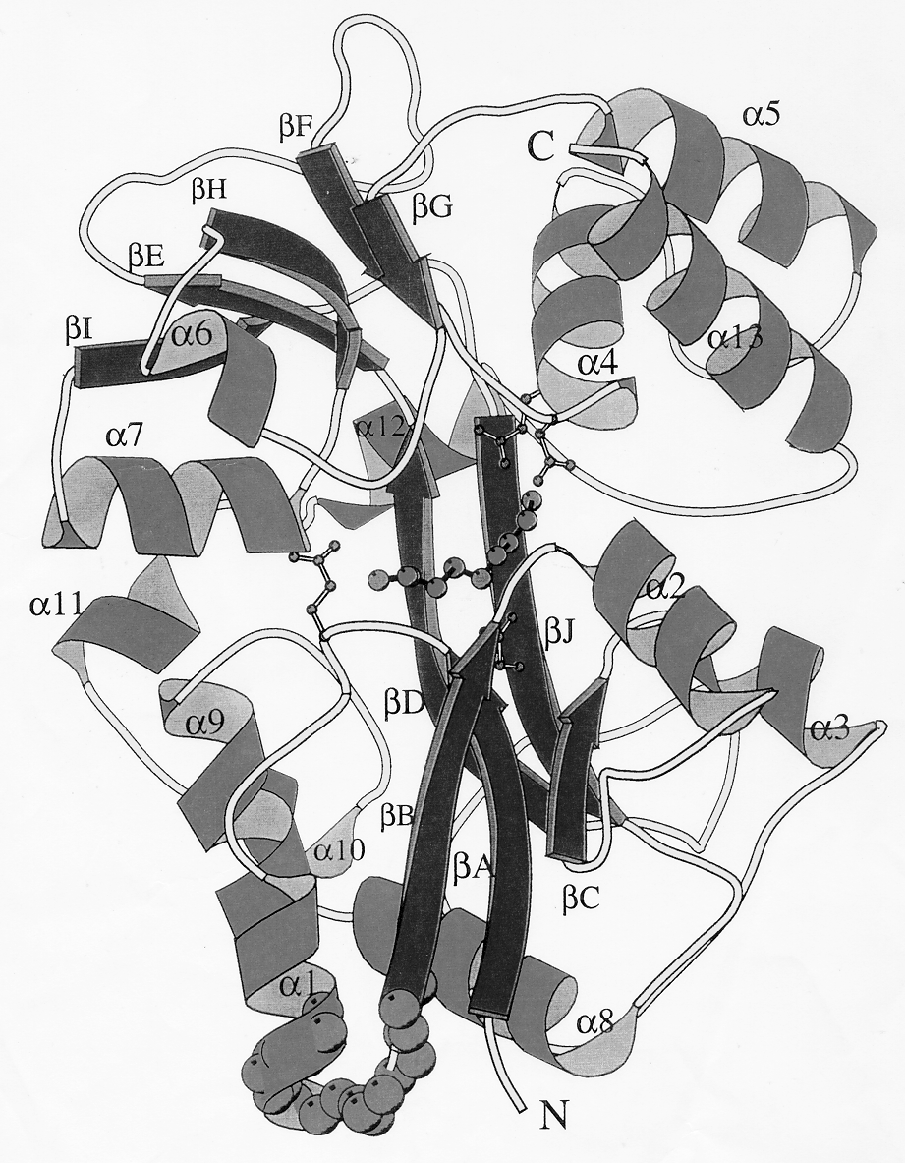
Fig. 1. Structure of PotD protein.

Fig. 2 Spermidine-binding site of PotD protein.
Shadowed boxes most strongly involved amino acid; shaded ovals, moderately involved amino acid; white boxes weakly involved amino aicd.

