Instruction for Authors

Taro Meidai ⁽¹⁾ and Hanako Meidai ⁽²⁾
(1) Graduate School of Biomagnetism, Nagoya University
(2) Shachi-hoko Research Center, Nagoya Castle University

Abstract The abstract with about 100 words should be presented here. It is preferable that all authors write the abstract of the proceedings paper in English.

1. Before you start
Your manuscript should be the camera-ready master for the offset printing of the paper⁽¹⁾. Based on this Instruction for Authors, please submit your manuscript in two or three pages with figures, photos, and tables pasted onto the document and the layout complete.

2. Size of the manuscript
Create your document on an A4-size sheet. A double-page spread is allocated for each manuscript. Leave 35 mm margin for top and bottom, 20 mm for right and left. Create your document inside the margin; please do not write in the margin. The manuscript will be printed by trimming away 10 mm from top and bottom, as an A4-variant size.

3. Format
(1) Please write in the following order.
In the first line, title (font type Times New Roman, Bold style, size 16pt); in the second line, authors and organization in English (font type Times New Roman, size 12pt). Please indicate all affiliations with a superscript number immediately after the author's name and in front of the appropriate address.
(2) Please use 10.5pt Times New Roman and a double-column format. Line space may be adjusted as appropriate.
(3) Head each section with numbered titles (font type Times New Roman, Bold style, size 10.5 pt) such as 1.Introduction, 2. Materials and Methods, 3. Results, 4. Discussion, and so on, for your paper to be easily comprehensible.
4. Figures, Photos, and Tables
Please use a clear image. One of three, or two, pages can contain color figures and tables. Please put captions at the bottom for a figure or a photo, and on the top for a table. Indicate reference with suffix⁽¹⁾ in the main text and a list of reference at the end of the paper in the manner shown on this page.

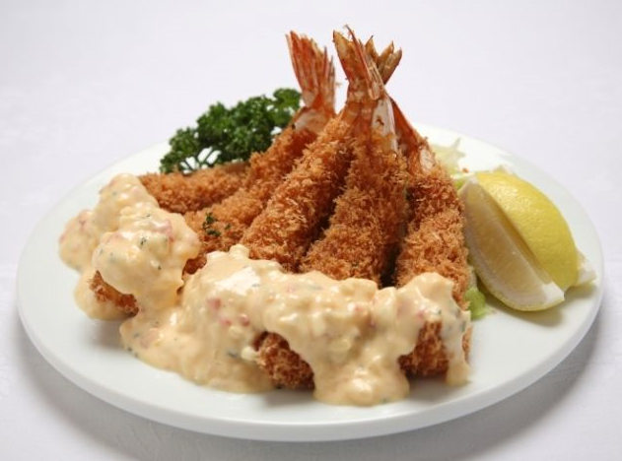
Fig.1 Ebi-fly.

5. Sending the manuscript
Manuscripts should be sent in both Adobe PDF format AND Microsoft Word format as an attached file of an e-mail to:
biomag35-gakkai@umin.org
Deadline: May 10, 2020

Please title your e-mail as
Author_Name_Manuscript
e.g) Meidai_Taro_Manuscript

Please title the attached file name as
Author_Name.pdf
Author_Name.docx

e.g) Meidai_Taro.pdf
e.g) Meidai_Taro.docx

Add a number to the end when submitting multiple papers.

e.g) Meidai_Taro_02.pdf
e.g) Meidai_Taro_02.docx

References
[1] Meidai T, Meidai H. (2019) Instruction for authors. J. Japan Biomag. Bioelectromag. Soc. 20:1-10.
[2] Meidai T, Meidai H, Tokai K et al. (2020) Recent advantages in biomagnetism. Biomagnetism 999:999-9999.

When you can publish your contact email, please write it at the end.

Meidai Taro: Meidai@taro.ac.jp

